FRCS (Neurosurgery) Viva Course
Aberdeen Royal Infirmary
Saturday & Sunday 18-19th February 2017

Our course text book:
Neurosurgery: The Essential Guide to the Oral and Clinical Neurosurgical Exam Vivian A. Elwell, Ramez Kirollos and Syed Al-Haddad

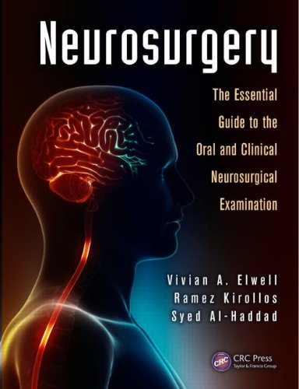
The course provides a ‘dry-run’ of the Part 2 FRCS(NS) examination for neurosurgeons in training in conditions as close to the real thing as possible. Day one covers Clinicals and day two covers Vivas. A variety of experienced senior consultants and those who have recently passed the exam are included in the faculty.
‘Having done the exam last time I would strongly recommend this course for anyone doing the clinical. It is exactly like the exam and got me well prepared for it.’
Cost = £350 including course meal
Places are limited to 16 candidates only on a ‘first come, first served’ basis.

To book the course and any further information contact:

Mr Peter Bodkin
peterbodkin@nhs.net
Consultant Neurosurgeon
Aberdeen Royal Infirmary
AB25 2ZN

