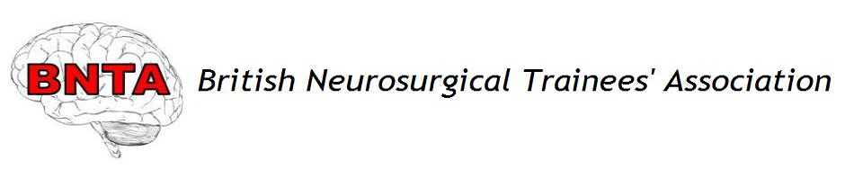

BNTA–Codman Award Application 2021

Please return the completed form to the BNTA Treasurer at drcpm@liverpool.ac.uk by 5pm on Monday 9th August 2021

Personal Details:

Name:

Address:

Email:

Telephone:

Current level of training:

FRCS(SN): Full FRCS / FRCS Part I / Neither [delete as appropriate]

Workplace/Deanery:

Training number:

Fellowship details:

Proposed Fellowship:

Subspecialty:

Start Date:

End Date:

Location:

Convenor / Supervisor:

Alternative sources of funding sought:

Please outline how the proposed fellowship will benefit your professional development and sub-specialty training, and to what use the BNTA-Codman Fellowship funding would be put (max 300 words):

BNTA Codman Award notes

- The BNTA Codman Award is open to all BNTA members undertaking recognised Fellowship Programs with a CCT who do not yet have a Consultant post, or to those with a valid National Training Number undertaking Fellowships within their training years.
- 5 x £1,000 fellowship awards are available.
- Previous successful applicants of the BNTA Codman fellowship may apply but priority will be given to first time applicants to the fund, to trainees pursuing Fellowship opportunities abroad, and to those who can demonstrate evidence of financial hardship.
- All applications will be anonymised and impartially assessed by a panel of senior Consultant Neurosurgeons.
- The decision of the awarding committee is final in all matters.
- Members of the BNTA Committee will be ineligible for application.
- It is expected that alternative sources of funding will be sought. Applicants should not be solely reliant on funding from this award as delays/changes in the total award value may occur that are beyond the BNTA’s control. The time taken for awarded sums to be received also cannot be guaranteed.
- Successful applicants may receive all, or part of the sum applied for.
- Applicants must provide evidence of taking up their proposed Fellowship Program post within 1 month of the stated start date. This can take the form of a signed letter on headed notepaper from the Convenor / Supervisor of the Fellowship.
- Successful applicants will receive their fellowship award via postal cheque or bank transfer.
- A condition of the award is that successful applicants write a 1,000 word report for publication on the BNTA website, www.e1v1m1.co.uk, within a month of completion of the awarded Fellowship period.
- Please do not hesitate to contact the BNTA Treasurer if you have any queries: drcpm@liverpool.ac.uk

